Internship Report on
Digital Marketing at
EduPhoenix Solutions, RT Nagar

Submitted in Partial Fulfilment of the Requirements of
Bachelor Of Commerce Degree of Bengaluru North University

BY

REG NO - UUCMS ID
UNDER THE GUIDANCE OF
_____________________________

ACKNOWLEDGEMENT

The successful completion of this internship report required significant guidance and assistance from many individuals, and I am truly grateful for their support throughout this journey.
Firstly, I would like to express my sincere appreciation to Mr. Garvit Garg, who provided me with the invaluable opportunity to intern at EduPhoenix Solutions. His guidance and mentorship were instrumental in my professional development and learning experience during this internship.
I am also deeply grateful to our faculty coordinator, Mr. [Name], and our principal, Dr. [Name], for their unwavering support and for granting me the valuable opportunity to intern, which has been pivotal in my exposure to the field of digital marketing.
I would like to extend my heartfelt thanks to my parents for their permission and constant encouragement throughout this internship. Additionally, I am thankful to my friends for their support whenever I needed their assistance during this project.
Lastly, I would like to express my profound gratitude to all individuals who directly or indirectly contributed to the completion of this report.

TABLE OF CONTENTS

Chapter No. |  | Title | Page No.
 | CERTIFICATE OF INTERNSHIP |  | i
 | COLLEGE CERTIFICATE |  | ii
 | STUDENT DECLARATION |  | iii
 | ACKNOWLEDGEMENT |  | iv
 | TABLE OF CONTENTS |  | v
1 |  | Company | 1
2 |  | Domain: Digital Marketing | 18
3 |  | Internship Tasks/ Daily logs | 30
4 |  | Project | 35
5 |  | Career Opportunities | 40
6 |  | Future Trends | 42
7 |  | Conclusion | 44
8 |  | References | 45

CHAPTER 1
COMPANY
  - Company Profile
EduPhoenix Solutions is a dynamic and innovative company dedicated to providing cutting-edge solutions in the field of education technology. Established with a vision to revolutionize learning experiences, EduPhoenix Solutions offers a comprehensive range of products and services tailored to meet the evolving needs of educational institutions, students, and educators.
At EduPhoenix Solutions, we leverage the latest advancements in technology to develop intuitive and interactive educational platforms, tools, and resources. Our team of experts is committed to designing and delivering solutions that enhance teaching effectiveness, engage learners, and foster academic success.
From e-learning platforms and virtual classrooms to customized educational software and mobile applications, EduPhoenix Solutions offers a diverse portfolio of products aimed at transforming traditional learning paradigms. We prioritize user-centric design, ensuring that our solutions are user-friendly, accessible, and adaptable to diverse learning environments.

Figure 1.1 Company Logo
In addition to our innovative products, EduPhoenix Solutions provides consultancy services, training programs, and ongoing support to help educational institutions maximize the impact of technology on teaching and learning outcomes. Our collaborative approach enables us to work closely with clients to understand their unique challenges and goals, delivering tailored solutions that drive positive change and innovation.
EduPhoenix Solutions stands at the forefront of educational technology, driven by a passion for innovation and a commitment to excellence. With a deep understanding of the challenges facing modern educational institutions, we offer a comprehensive suite of solutions designed to elevate teaching and learning experiences to new heights.
Our team of experts combines extensive experience in both education and technology to develop cutting-edge platforms and tools that empower educators and engage learners. By harnessing the latest advancements in artificial intelligence, data analytics, and user-centric design, we create intuitive and immersive learning environments that foster creativity, critical thinking, and collaboration.
Beyond our innovative products, EduPhoenix Solutions provides strategic consultancy services and professional development programs to support educational institutions in leveraging technology effectively. From needs assessment and solution design to implementation and ongoing support, we partner with our clients every step of the way to ensure the success of their digital initiatives.
With a strong focus on user experience, accessibility, and scalability, our solutions are tailored to meet the unique needs of diverse educational settings, from K-12 schools to higher education institutions and corporate training programs. By delivering customizable, adaptable, and future-ready solutions, we empower educators to deliver high-quality instruction and empower learners to achieve their full potential in an increasingly digital world.
Driven by a shared vision of transforming education through technology, EduPhoenix Solutions is dedicated to pushing the boundaries of innovation and driving positive change in the education landscape. As we continue to evolve and expand our offerings, we remain steadfast in our commitment to delivering impactful solutions that inspire lifelong learning and shape the future of education.
With a commitment to excellence, integrity, and continuous improvement, EduPhoenix Solutions is dedicated to empowering educators, inspiring learners, and shaping the future of education through technology. We are proud to partner with educational institutions worldwide, helping them unlock the full potential of digital learning in the 21st century.

1.2 Company Overview
EduPhoenix Solutions is a dynamic and forward-thinking company that specializes in providing innovative educational technology solutions to institutions worldwide. Established with a vision to revolutionize the way education is delivered and experienced, EduPhoenix Solutions has quickly emerged as a leader in the field, offering a wide range of cutting-edge products and services tailored to meet the diverse needs of educators and learners alike.
At EduPhoenix Solutions, we believe that technology has the power to transform education by making learning more accessible, engaging, and effective. With this belief at the core of our mission, we strive to develop solutions that empower educators to deliver high-quality instruction and enable learners to reach their full potential.
Our comprehensive suite of products and services encompasses everything from learning management systems and virtual classrooms to interactive content authoring tools and professional development programs. Whether it's providing educators with the tools they need to create immersive learning experiences or offering learners access to dynamic and interactive learning environments, EduPhoenix Solutions is committed to driving positive change in education through technology.
One of the key strengths of EduPhoenix Solutions lies in our team of experts, who bring a wealth of experience and expertise from diverse fields such as education, technology, instructional design, and user experience. By combining our knowledge and skills, we are able to develop innovative solutions that address the evolving needs of the education sector and deliver measurable results.
In addition to our product offerings, EduPhoenix Solutions also provides consultancy services to educational institutions seeking to leverage technology effectively. From needs assessment and solution design to implementation and ongoing support, our team works closely with clients to develop customized strategies and solutions that align with their unique goals and objectives.
As a company, we are deeply committed to excellence, integrity, and customer satisfaction. We take pride in our ability to deliver high-quality products and services that meet the highest standards of quality and reliability. With a customer-centric approach and a focus on continuous improvement, we strive to exceed our clients' expectations and build long-lasting partnerships based on trust and mutual respect.

  - Company Departments
EduPhoenix Solutions operates across several departments, each contributing to the overall mission of delivering innovative educational solutions and services. These departments include:

Human Resources (HR) Department:
Recruitment and Talent Acquisition: This involves identifying staffing needs, sourcing candidates through job postings and recruitment agencies, conducting interviews, and selecting the best-fit candidates.
Employee Onboarding and Orientation: HR ensures that new hires receive necessary training, complete required paperwork, understand company policies, and integrate smoothly into their roles and the organization.
Performance Management: HR oversees performance evaluations, goal setting, feedback mechanisms, and recognition programs to foster employee growth, development, and engagement.
Employee Relations: This department handles employee grievances, conflicts, disciplinary actions, and ensures compliance with employment laws and regulations.
Training and Development: HR designs and implements training programs, workshops, and seminars to enhance employee skills, competencies, and professional development opportunities.
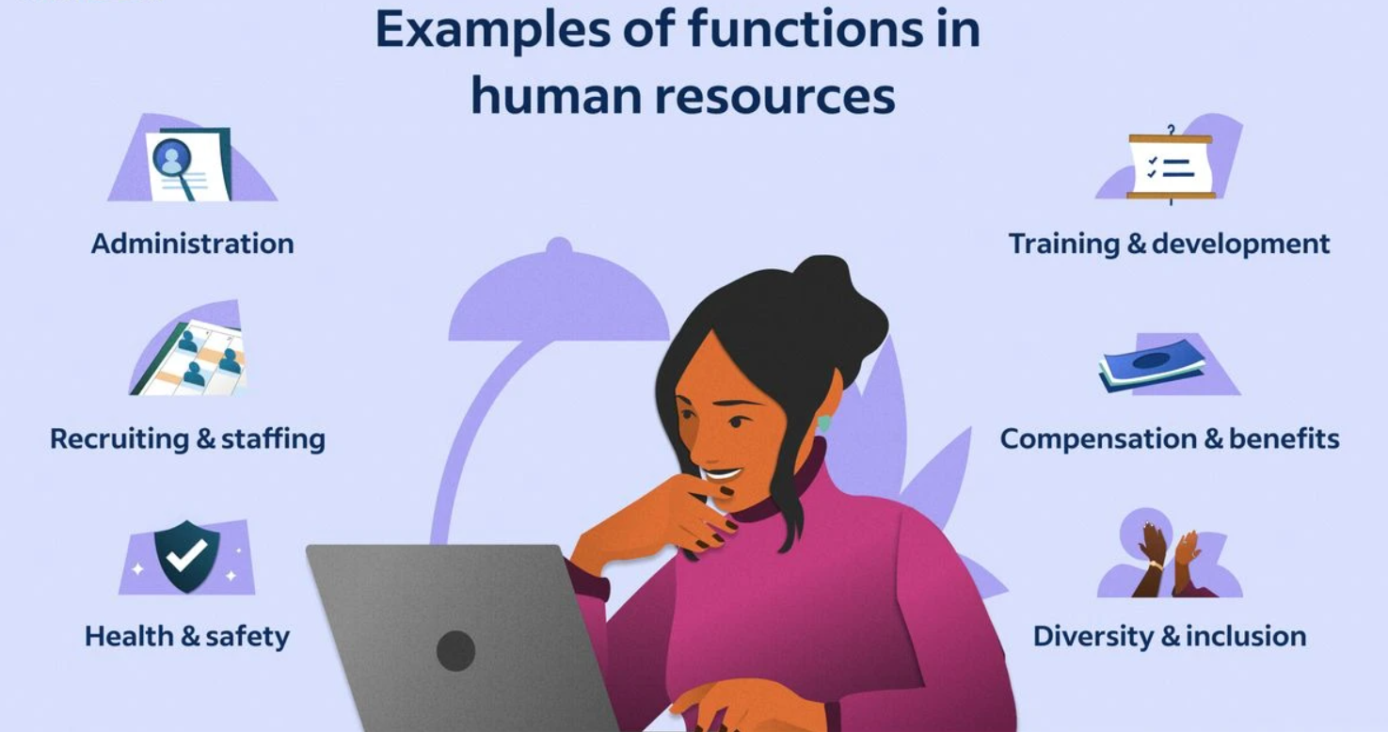
Figure 1.3.1 Functions of Human Resources (HR)

Information Technology (IT) and Technical Support Department:
Infrastructure Management: This includes managing servers, networks, hardware, and software systems to ensure seamless operation, security, and scalability.
Systems Administration: IT administrators monitor system performance, troubleshoot technical issues, install updates, and ensure data backups and recovery protocols are in place.
Cybersecurity: This team protects the organization from cyber threats by implementing firewalls, antivirus software, intrusion detection systems (IDS), and conducting regular security audits and assessments.
Software Development: IT professionals develop and maintain custom software applications, websites, and digital platforms to support internal operations and customer-facing solutions.
Technical Support: The IT helpdesk provides technical assistance, resolves user issues, and offers guidance on software usage, hardware configuration, and network connectivity.
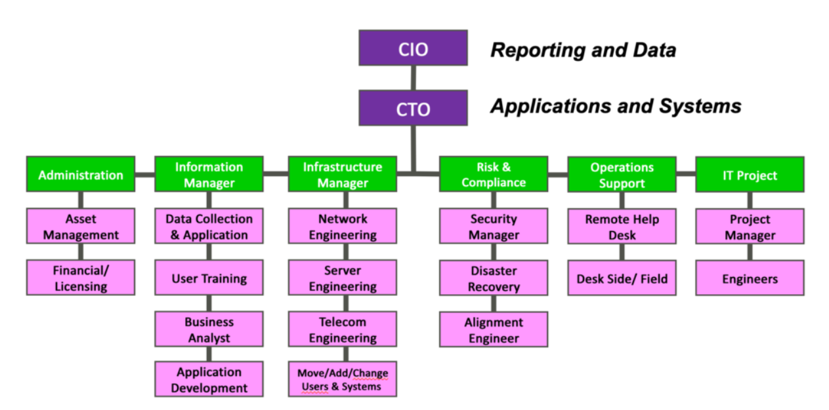
Figure 1.3.2 Information Technology (IT) Department Structure

Research and Development (R&D) Department:
Market Research and Analysis: R&D conducts market research to identify industry trends, customer preferences, and competitive landscapes to inform product development strategies.
Product Innovation: This team conceptualizes and prototypes new products, features, and services, leveraging emerging technologies and customer feedback to drive innovation.
Prototype Development: R&D builds and tests prototypes to validate concepts, assess feasibility, and gather user feedback before full-scale development and commercialization.
Intellectual Property Management: This involves securing patents, trademarks, and copyrights to protect the organization's innovations, inventions, and creative works from infringement.
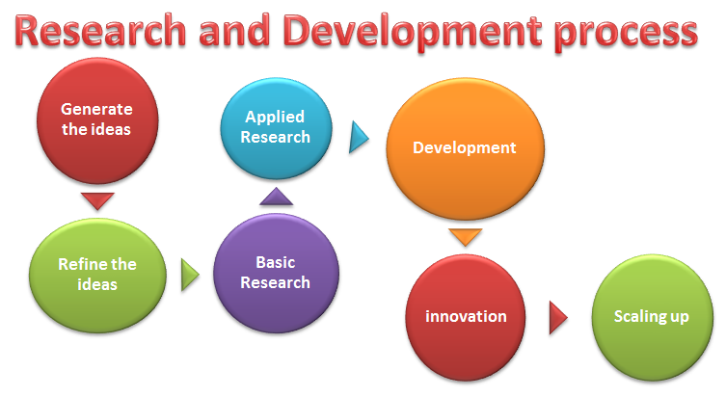
Figure1.3.3 Research & Development Process

Sales and Marketing Department:Market Segmentation and Targeting: Sales and marketing professionals identify and segment target markets based on demographics, behaviors, and preferences to tailor marketing messages and campaigns.
Lead Generation and Nurturing: This team generates leads through advertising, content marketing, and networking efforts, then nurtures those leads through email campaigns, follow-up calls, and personalized communication.
Brand Management: Sales and marketing professionals develop brand identity, messaging, and positioning strategies to differentiate EduPhoenix Solutions from competitors and build brand loyalty.
Digital Marketing: This involves leveraging digital channels such as websites, social media platforms, search engine optimization (SEO), and pay-per-click (PPC) advertising to reach and engage target audiences.
Sales Enablement: Sales enablement teams provide sales reps with the tools, resources, and training needed to effectively communicate product features, benefits, and value propositions to prospects and customers.

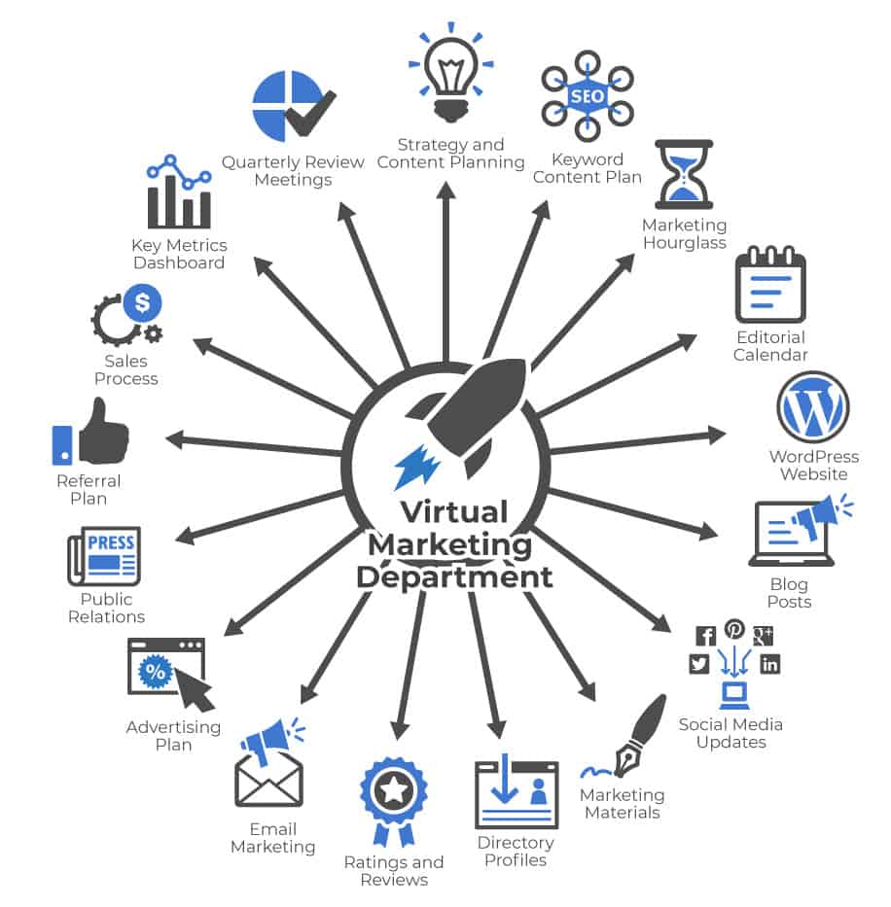
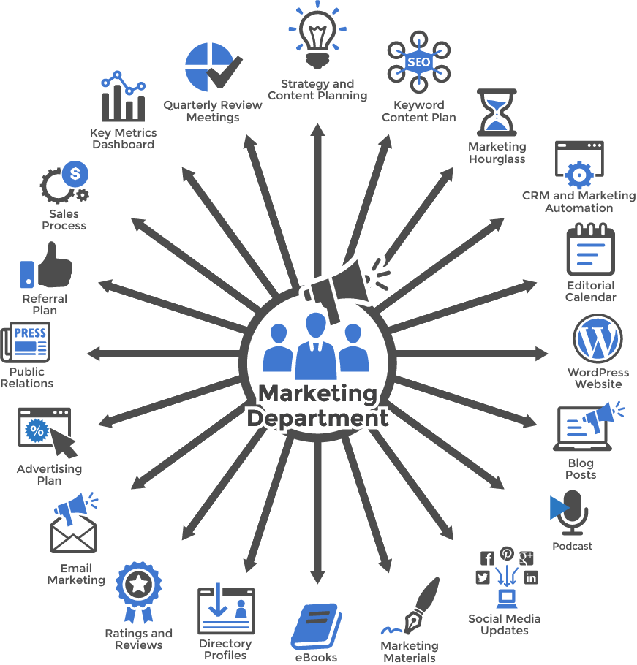
Figure 1.3.4(a) Virtual Marketing  Department | Figure 1.3.4(b) Marketing  Department

Customer Success Department:
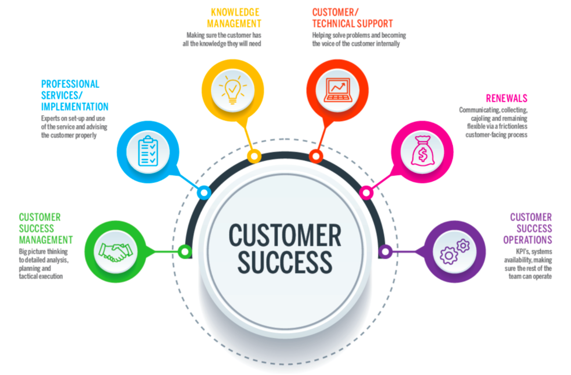
Customer Onboarding: This involves guiding new customers through the implementation process, providing training, support, and resources to ensure successful adoption and utilization of EduPhoenix Solutions.
Figure 1.3.5 Customer Success
Customer Relationship Management: Customer success managers build and nurture relationships with clients, acting as their advocate within the organization and ensuring their needs and expectations are met.
Account Management: This team is responsible for managing customer accounts, identifying upsell and cross-sell opportunities, and fostering long-term relationships to drive retention and expansion.
Customer Support: The customer support team provides responsive assistance, troubleshooting, and issue resolution to address customer inquiries, technical challenges, and service disruptions effectively.

Finance and Accounting Department:
Financial Planning and Analysis: This department is responsible for budgeting, forecasting, financial modeling, and providing insights to support strategic decision-making.
Accounts Payable and Receivable: Finance professionals manage payments to vendors, invoicing customers, and tracking receivables to ensure timely cash flow management.
Financial Reporting and Compliance: This team prepares financial statements, regulatory filings, and ensures compliance with accounting standards, tax laws, and industry regulations.
Treasury Management: Finance professionals oversee cash management, investment strategies, and risk mitigation to optimize liquidity and financial stability.

Figure 1.3.6 Finance & Accounting

Legal and Compliance Department:
Contract Management: Legal professionals draft, review, and negotiate contracts with clients, partners, and vendors to protect EduPhoenix Solutions' interests and mitigate legal risks.
Regulatory Compliance: This team ensures compliance with laws, regulations, and industry standards related to data privacy, security, intellectual property, and consumer protection.
Intellectual Property (IP) Management: Legal experts manage EduPhoenix Solutions' intellectual property portfolio, including patents, trademarks, copyrights, and trade secrets.
Risk Management: The legal and compliance department identifies, assesses, and manages legal and regulatory risks to minimize exposure and protect the organization from liabilities.
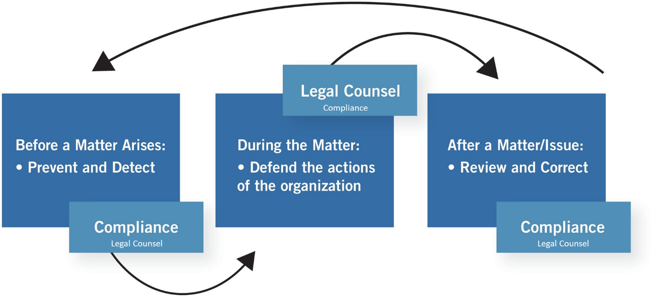
Figure 1.3.7 Legal & Compliance Procedure

Operations and Logistics Department:
Supply Chain Management: Operations professionals oversee procurement, inventory management, and logistics to ensure timely delivery of goods and services while optimizing costs and efficiency.
Facilities Management: This team maintains and manages office facilities, equipment, and infrastructure to create a safe, productive, and comfortable work environment.
Quality Assurance and Control: Operations experts develop and implement quality standards, processes, and metrics to ensure products and services meet or exceed customer expectations.

Figure 1.3.8(a) Operations  Management | Figure 1.3.8(b) Logistics

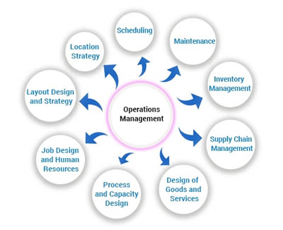
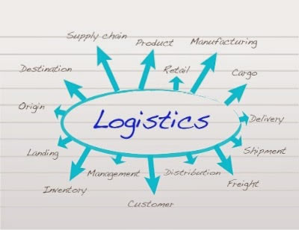
Project Management: Operations professionals coordinate cross-functional projects, allocate resources, and track progress to ensure timely completion and successful outcomes.

Customer Experience Department:
User Experience (UX) Design: This team focuses on designing intuitive, user-friendly interfaces and interactions for digital products and platforms to enhance customer satisfaction and engagement.
Customer Insights and Analytics: CX professionals analyze customer feedback, behavior data, and performance metrics to gain actionable insights and drive continuous improvement initiatives.
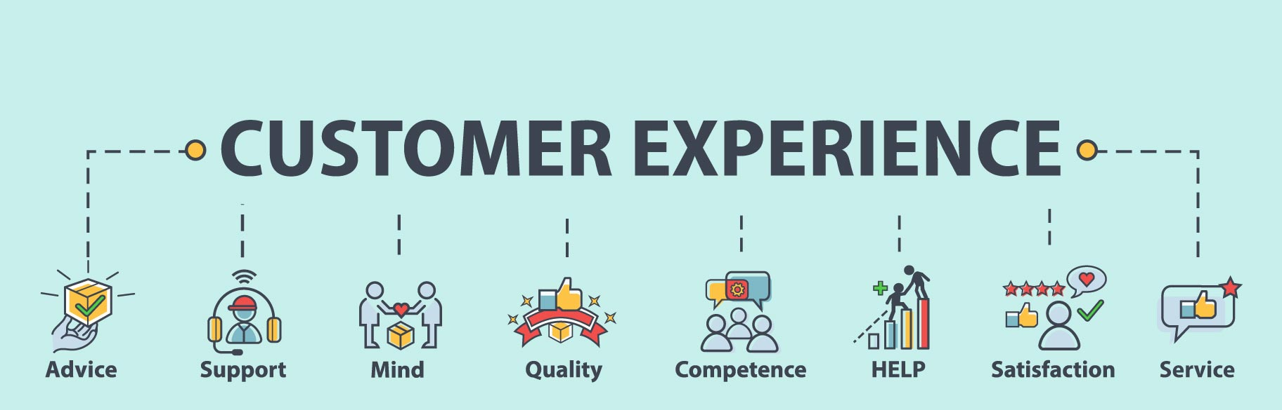
Customer Advocacy: This department represents the voice of the customer within the organization, advocating for their needs, preferences, and concerns to inform product development and decision-making.
Figure 1.3.9 Customer Experience
Customer Satisfaction and Retention: CX professionals develop strategies and programs to measure and improve customer satisfaction, loyalty, and retention rates through proactive engagement and personalized experiences.

Business Development and Partnerships Department:
Strategic Partnerships: Business development professionals identify and cultivate strategic alliances, joint ventures, and partnerships with other companies to expand market reach, access new resources, and drive growth.
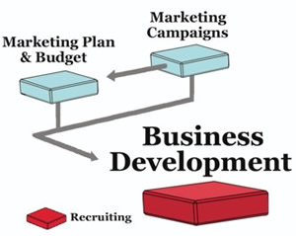
Market Expansion: This team explores new markets, geographies, and customer segments to identify growth opportunities and develop market entry strategies to capitalize on emerging trends.
Channel Development: Business development experts establish and manage distribution channels, reseller networks, and affiliate programs to extend EduPhoenix Solutions' reach and increase sales volume.
Competitive Intelligence: This department monitors competitors' activities, market trends, and industry developments to identify threats and opportunities, inform strategic decision-making, and maintain a competitive edge. Figure 1.3.10 Business Development

Quality Assurance and Testing Department:
Quality Assurance (QA) Testing is a critical function that ensures products and services meet specified quality standards before they are released to customers. This involves systematically testing various aspects of software, hardware, or other deliverables to identify defects or areas for improvement.
QA testers develop comprehensive test plans, scenarios, and scripts based on project requirements and specifications. These documents outline the testing approach, test cases, and expected outcomes for each test scenario.
Different types of testing are performed throughout the development lifecycle, including functional testing, which verifies that the system meets specified functional requirements, and regression testing, which ensures that new changes do not adversely impact existing functionality.

Figure 1.3.11(a) Quality Assurance | Figure 1.3.11(b) Testing

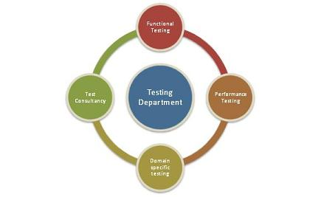
User acceptance testing (UAT) is conducted to validate the product against user expectations and requirements. This involves engaging end-users to evaluate the product's usability, accessibility, and overall user experience.
QA testers use a variety of testing techniques and tools to identify defects and bugs in the system. This may include manual testing, automated testing, performance testing, security testing, and usability testing, among others.
Throughout the testing process, QA testers document their findings, including any defects or issues discovered during testing. They work closely with development teams to prioritize and address these issues, ensuring that high-priority defects are resolved promptly.
Continuous improvement is a key aspect of QA testing, with testers regularly reviewing and refining testing processes and methodologies to enhance efficiency and effectiveness. This may involve implementing new tools, adopting best practices, and incorporating feedback from stakeholders to drive quality improvements.
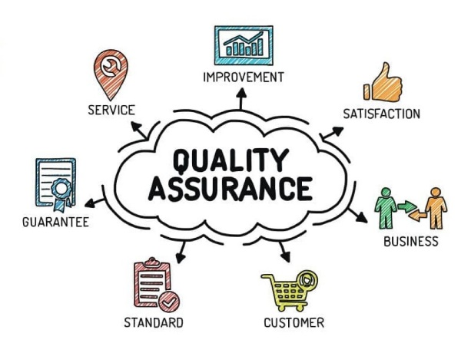
Grievance and Conflict Resolution Department:
The Grievance and Conflict Resolution department is responsible for managing disputes, grievances, and conflicts within the organization. This department serves as a neutral mediator, helping parties resolve issues in a fair and equitable manner.
One of the primary functions is to provide employees and stakeholders with a platform to express their concerns and grievances. This could involve setting up confidential reporting mechanisms, such as hotlines or online portals, where individuals can raise issues anonymously.
The department investigates complaints and conflicts thoroughly, gathering relevant information and evidence to understand the root causes of the problem. Depending on the nature of the issue, this may involve conducting interviews, reviewing documentation, or engaging in alternative dispute resolution methods like mediation or arbitration.
Once the investigation is complete, the department works towards finding a resolution that addresses the concerns of all parties involved. This could involve implementing corrective actions, revising policies or procedures, or providing training and support to prevent similar issues from arising in the future.
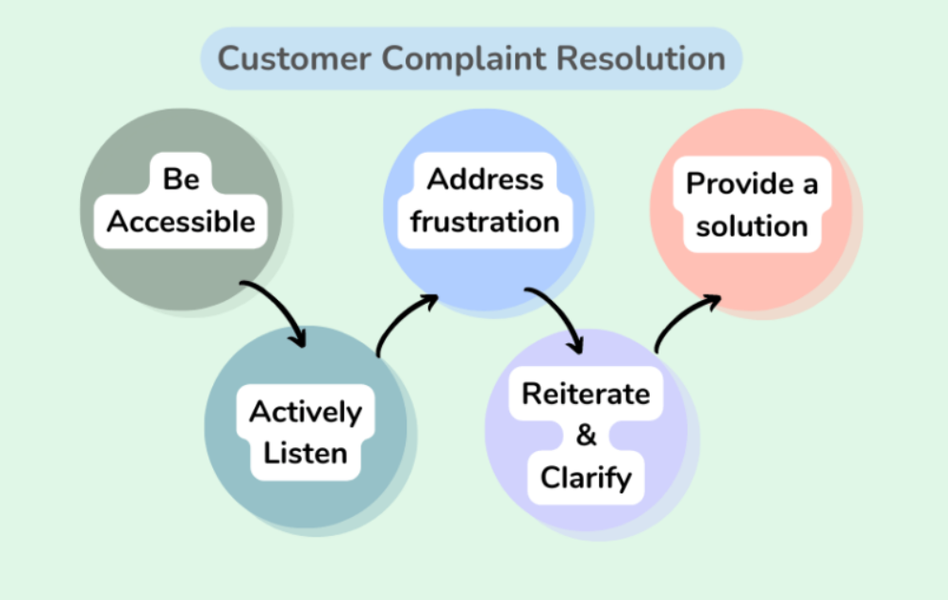
Figure 1.3.12 Customer Complaint Resolution
Additionally, the Grievance and Conflict Resolution department may play a role in promoting a positive organizational culture by fostering open communication, trust, and collaboration among employees. This includes promoting conflict resolution skills and providing resources for managing interpersonal conflicts effectively.

These departments play integral roles in ensuring the success and growth of EduPhoenix Solutions by effectively managing resources, delivering high-quality products and services, and delivers comprehensive educational solutions that empower learners, educators, and institutions to succeed in a rapidly evolving digital landscape.

  - Company Products/Applications
EduPhoenix Solutions prides itself on offering a diverse array of cutting-edge educational technology products and applications designed to cater to the evolving needs of educators and learners alike. Our commitment to innovation and excellence drives us to develop solutions that enhance teaching effectiveness, promote student engagement, and ultimately elevate the learning experience. Here's a detailed overview of our key products and applications:
- Learning Management System (LMS):
Our Learning Management System (LMS) serves as the cornerstone of our educational technology suite. This robust platform provides educators with the tools they need to create, deliver, and manage online courses and educational content seamlessly. With intuitive course creation features, comprehensive content management capabilities, and robust assessment tools, our LMS empowers educators to design dynamic and interactive learning experiences. Moreover, real-time analytics and reporting functionalities enable educators to monitor student progress and performance effectively.

- Virtual Classroom:
In today's digital age, our Virtual Classroom platform offers educators a versatile and immersive online learning environment. Equipped with video conferencing, screen sharing, interactive whiteboards, and chat functionality, this platform facilitates real-time collaboration and interaction between educators and students. Whether conducting live classes, webinars, or virtual workshops, educators can engage learners effectively and foster meaningful learning experiences. Seamless integration with our LMS ensures streamlined course delivery and administration.

- Interactive Content Authoring Tools:
Our suite of interactive content authoring tools empowers educators to create engaging and multimedia-rich learning materials with ease. Featuring user-friendly interfaces, customizable templates, and multimedia integration capabilities, these authoring tools enable educators to develop interactive presentations, quizzes, simulations, and games effortlessly. With built-in assessment and tracking features, educators can assess student comprehension and progress in real time, ensuring that learning objectives are met effectively.

- Professional Development Programs:
Recognizing the importance of continuous professional development, we offer a wide range of training courses and programs designed to enhance educators' skills and knowledge in educational technology and pedagogy. From digital literacy and blended learning to instructional design and technology integration, our professional development programs cover a diverse array of topics. Whether educators are looking to expand their expertise in specific areas or earn certifications in educational technology, our programs provide valuable opportunities for growth and advancement.
- Consultancy Services:
Our consultancy services cater to educational institutions seeking expert guidance and support in leveraging technology for teaching and learning. Our team of seasoned consultants collaborates closely with clients to assess their unique needs, develop tailored technology solutions, and provide ongoing training and support. From strategic planning and needs analysis to implementation and evaluation, our consultancy services empower institutions to maximize the impact of educational technology and achieve their educational goals effectively.

- IoT Projects:
Internet of Things (IoT) projects involve the integration of physical devices, sensors, and software applications to enable connectivity and data exchange. These projects often focus on leveraging IoT technologies to create smart systems, automate processes, and gather insights from real-world data. Eduphoenix Solutions offers a range of IoT projects aimed at providing hands-on learning experiences to students and professionals.
These projects typically cover areas such as:
Sensor Integration: Students learn to integrate various sensors such as temperature sensors, humidity sensors, motion sensors, and environmental sensors into IoT devices and systems.
Data Acquisition and Processing: Projects involve collecting data from sensors and processing it using microcontrollers or single-board computers like Arduino, Raspberry Pi, or ESP8266/ESP32.
Connectivity and Communication: Students explore different communication protocols such as Wi-Fi, Bluetooth, Zigbee, and LoRa to enable connectivity between IoT devices and networks.
IoT Applications: Projects may focus on developing IoT applications for smart homes, smart cities, industrial automation, healthcare monitoring, environmental monitoring, agriculture, and more.
Cloud Integration: Integration with cloud platforms such as AWS IoT, Google Cloud IoT, or Microsoft Azure IoT enables students to store, analyze, and visualize IoT data, as well as implement cloud-based services like remote monitoring and control.
Security and Privacy: Emphasis is placed on implementing security measures such as encryption, authentication, and access control to protect IoT systems from cyber threats and ensure data privacy.

- AI-ML Projects:
Artificial Intelligence (AI) and Machine Learning (ML) projects involve the development and application of algorithms and models to analyze data, make predictions, and automate tasks without explicit programming instructions. These projects harness the power of AI and ML techniques to solve complex problems, optimize processes, and extract insights from data. Eduphoenix Solutions offers a variety of AI-ML projects aimed at fostering understanding and proficiency in these transformative technologies.
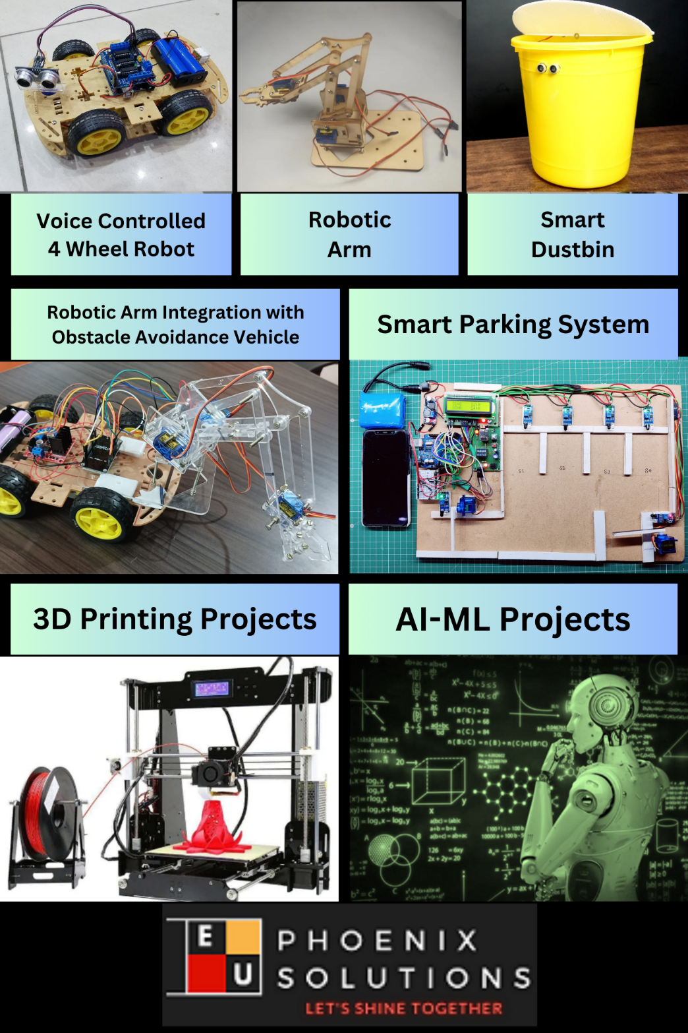

Figure 1.4.1 Company Products

Key components of AI-ML projects include:
Data Collection and Preparation: Projects begin with data collection from various sources such as sensors, databases, or web APIs. Data preprocessing techniques are then applied to clean, transform, and prepare the data for analysis.
Algorithm Selection and Model Development: Students explore different AI and ML algorithms such as regression, classification, clustering, neural networks, and deep learning to build predictive models and solve specific problems.
Model Training and Evaluation: The models are trained using abelled data, and their performance is evaluated using metrics such as accuracy, precision, recall, and F1-score. Hyperparameter tuning and cross-validation techniques are applied to optimize model performance.
Deployment and Integration: Once trained and evaluated, the models are deployed into production environments and integrated with existing systems or applications to deliver real-world value. This may involve deploying models on edge devices, cloud platforms, or IoT devices.

Overall, IoT and AI-ML projects offered by EduPhoenix Solutions provide participants with practical experience, critical thinking skills, and technical expertise in emerging technologies, preparing them for careers in the rapidly evolving fields of IoT and AI-ML.

CHAPTER 2
DOMAIN: DIGITAL MARKETING

2.1 Introduction
During my internship at EduPhoenix Solutions, I gained a comprehensive understanding of the fundamental principles and strategies of digital marketing. EduPhoenix Solutions is a leading digital marketing agency that specializes in helping businesses of all sizes leverage the power of the internet to reach and engage their target audience.
At the core of digital marketing is the ability to reach consumers through various online channels, such as search engines, social media, email, and content marketing. During my internship, I learned how to develop and implement effective digital marketing campaigns that drive traffic, generate leads, and ultimately, increase sales and revenue for clients.
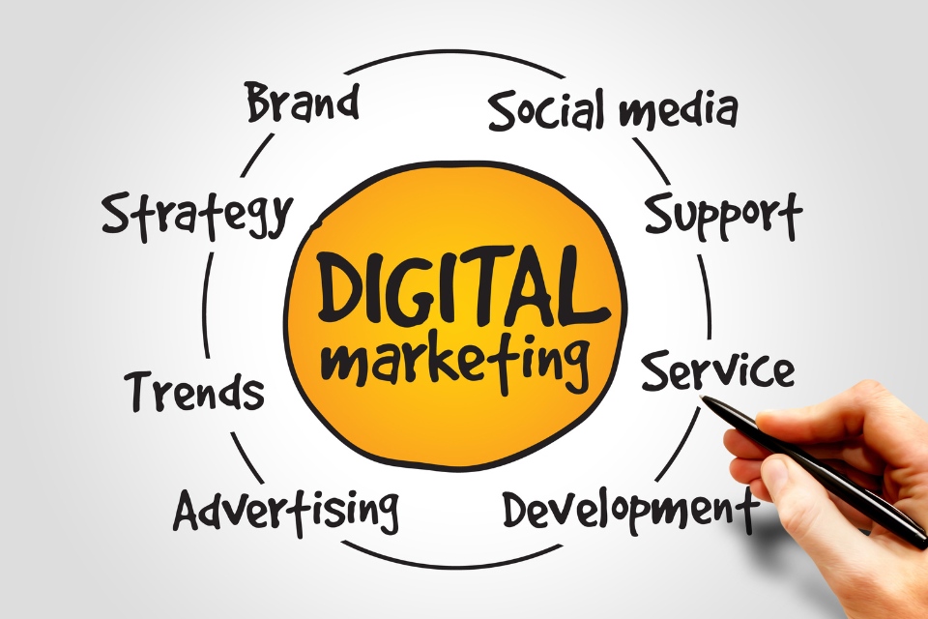
Figure 2.1 Digital Marketing
One of the key aspects of digital marketing that I focused on was search engine optimization (SEO). I learned how to conduct thorough keyword research, optimize website content, and implement technical SEO strategies to improve a client's visibility and ranking on search engine results pages (SERPs). Additionally, I gained experience in social media marketing, where I learned how to create engaging content, manage online communities, and leverage influencer partnerships to reach and connect with target audiences.
Another important component of digital marketing that I explored was content marketing. I learned how to create and distribute valuable, relevant, and consistent content to attract and retain a clearly defined audience, with the ultimate goal of driving profitable customer action. This included developing content strategies, creating high-quality content, and leveraging various distribution channels to reach the target audience.
Throughout my internship, I also gained hands-on experience with email marketing, web analytics, and digital advertising, including pay-per-click (PPC) campaigns and display advertising. I learned how to use various tools and platforms to measure and analyze the performance of digital marketing campaigns, and how to optimize these campaigns to achieve the desired results.
Overall, my internship at EduPhoenix Solutions provided me with a solid foundation in the core principles and strategies of digital marketing. I am now better equipped to help businesses leverage the power of the internet to reach and engage their target audience, drive traffic, generate leads, and ultimately, increase sales and revenue.
2.2 Overview
Digital marketing refers to the use of various digital channels and platforms to promote products, services, or brands to reach and engage with potential customers online. It encompasses a wide range of marketing activities carried out through digital technologies, including websites, social media, search engines, email, mobile apps, and other digital channels.
In today's digital age, businesses across industries are leveraging digital marketing strategies to connect with their target audience, increase brand visibility, drive website traffic, generate leads, and ultimately, boost sales and revenue. Unlike traditional marketing methods, digital marketing offers greater flexibility, measurability, and cost-effectiveness, allowing businesses to reach a wider audience and achieve better results with less investment.
Key Components of Digital Marketing:
- Website Marketing: A company's website serves as its online storefront and is often the first point of contact for potential customers. Effective website marketing involves optimizing the website's design, content, and user experience to attract visitors, encourage engagement, and drive conversions.
- Search Engine Optimization (SEO): SEO is the process of optimizing a website's content and structure to improve its visibility and ranking in search engine results pages (SERPs). By optimizing for relevant keywords and ensuring technical compliance, businesses can attract organic traffic from search engines and increase their online presence.
- Social Media Marketing: Social media platforms such as Facebook, Instagram, Twitter, LinkedIn, and YouTube offer powerful tools for businesses to connect with their target audience, build brand awareness, and foster customer relationships. Social media marketing involves creating and sharing engaging content, running targeted advertising campaigns, and interacting with followers to drive engagement and conversions.
- Content Marketing: Content marketing focuses on creating and distributing valuable, relevant, and informative content to attract and engage a specific audience. Content can take various forms, including blog posts, articles, videos, infographics, ebooks, and podcasts. By providing valuable content that addresses the needs and interests of their target audience, businesses can establish authority, build trust, and drive customer loyalty.
- Email Marketing: Email marketing remains one of the most effective digital marketing channels for nurturing leads, retaining customers, and driving conversions. Through targeted email campaigns, businesses can deliver personalized messages, promotions, and updates directly to subscribers' inboxes, driving engagement and encouraging action.
- Pay-Per-Click (PPC) Advertising: PPC advertising allows businesses to display ads on search engines and other digital platforms and pay only when users click on their ads. By targeting relevant keywords and demographics, businesses can drive targeted traffic to their websites and increase conversions through PPC campaigns.
- Affiliate Marketing: Affiliate marketing involves partnering with third-party affiliates or influencers who promote a company's products or services in exchange for a commission on sales. By leveraging the reach and influence of affiliates, businesses can expand their audience reach and drive sales through referral traffic.
- Analytics and Data Insights: Data analytics plays a crucial role in digital marketing, enabling businesses to track, measure, and analyze the performance of their marketing campaigns. By leveraging analytics tools and data insights, businesses can gain valuable insights into customer behavior, campaign effectiveness, and ROI, allowing them to optimize their strategies for better results.
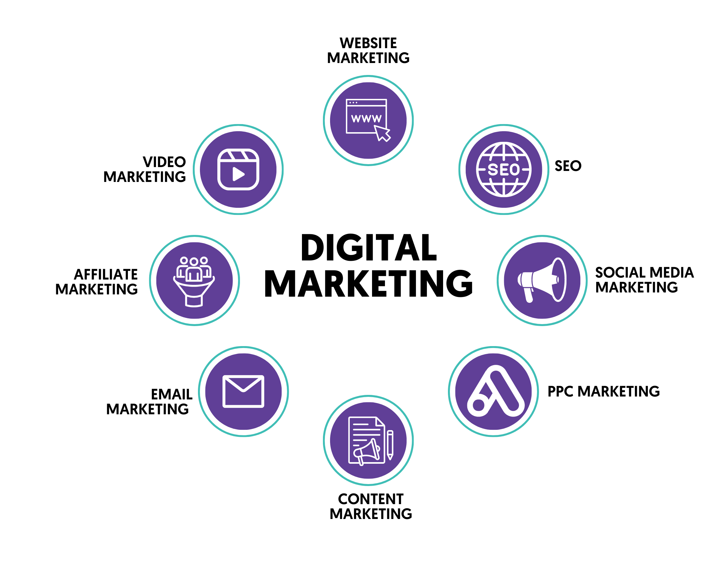
Figure 2.2 Components of Digital Marketing
In conclusion, digital marketing offers businesses a powerful and versatile toolkit for reaching and engaging with their target audience in today's digital landscape. By leveraging various digital channels and strategies, businesses can increase their online visibility, drive traffic and conversions, and ultimately, achieve their marketing objectives effectively and efficiently.

2.3 Search Engine Optimization (SEO)
During my internship at EduPhoenix Solutions, a leading digital marketing agency, I gained a deep understanding of the crucial role that search engine optimization (SEO) plays in the broader context of digital marketing. EduPhoenix Solutions specializes in helping businesses leverage the power of the internet to reach and engage their target audience, and SEO is a core component of their service offerings.
At the heart of SEO lies the ability to improve a website's visibility and ranking on search engine results pages (SERPs), which in turn, drives targeted traffic to the client's website. Throughout my internship, I learned the importance of conducting thorough keyword research to identify the most relevant and high-performing keywords for a client's business. This involved analyzing search volume, competition, and relevance to ensure that the targeted keywords aligned with the client's marketing objectives.
Armed with this knowledge, I then applied various on-page optimization techniques to the client's website content, including optimizing page titles, meta descriptions, headers, and body text. This allowed me to enhance the website's relevance and authority in the eyes of search engines, ultimately improving its ranking and visibility for the target keywords.
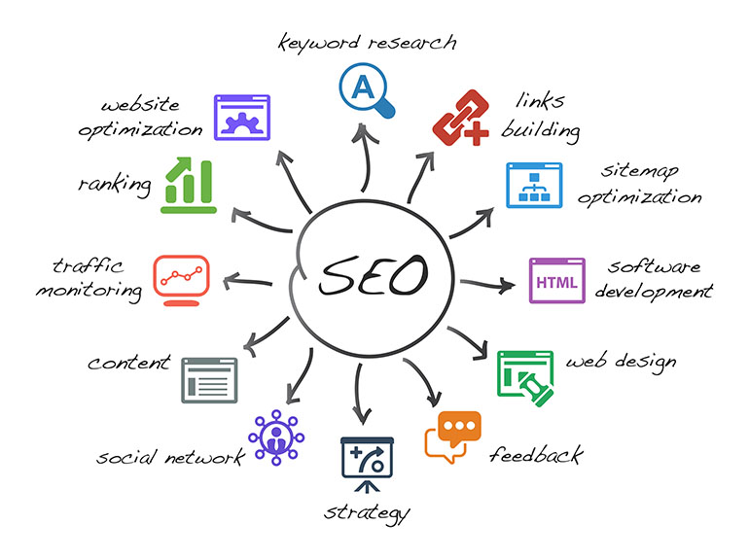
Figure 2.3 Search Engine Optimization (SEO)
In addition to on-page optimization, I also gained experience in implementing technical SEO strategies. This included addressing any site structure or technical issues that could potentially hinder the website's performance in search engines, such as improving site speed, optimizing images and videos, and ensuring the website's mobile responsiveness.
By leveraging these SEO best practices, I was able to help clients improve their online presence and reach their target audience more effectively. I witnessed firsthand the tangible impact that SEO can have on driving qualified traffic, generating leads, and ultimately, increasing sales and revenue for businesses.
Throughout my internship, I also learned the importance of tracking and analyzing SEO performance using various tools and platforms, such as Google Analytics and Google Search Console. This allowed me to measure the success of the SEO strategies implemented and make data-driven decisions to optimize the campaigns further.
In conclusion, my internship at EduPhoenix Solutions provided me with a comprehensive understanding of the critical role that SEO plays in the broader context of digital marketing. I now possess the knowledge and skills to help businesses enhance their online visibility, attract targeted traffic, and achieve their marketing objectives through effective search engine optimization.

2.4 Content Marketing
During my internship at EduPhoenix Solutions, a leading digital marketing agency, I gained invaluable insights into the significant role that content marketing plays in the overall digital marketing landscape. EduPhoenix Solutions is renowned for its expertise in helping businesses leverage the power of the internet to reach and engage their target audience, and content marketing is a core component of their service offerings.
At the heart of content marketing lies the creation and distribution of valuable, relevant, and consistent content that attracts and retains a clearly defined audience. Throughout my internship, I learned how to develop and execute content strategies that align with the client's overall marketing objectives, whether it's driving website traffic, generating leads, or building brand awareness.
I began by conducting thorough research to understand the client's target audience, their pain points, and their content preferences. Armed with this knowledge, I was able to ideate and create high-quality content in various formats, including blog posts, videos, infographics, and e-books. The goal was to provide the target audience with informative, engaging, and actionable content that would position the client as a thought leader in their respective industry.
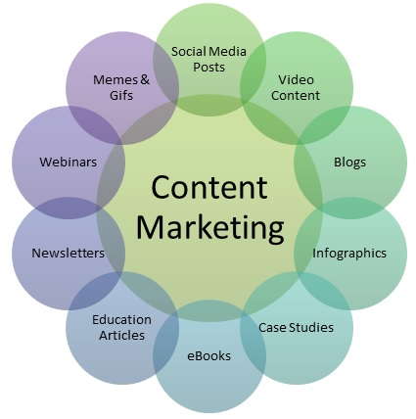
Figure 2.4 Content Marketing
In addition to creating the content, I also gained experience in distributing and promoting it across various channels, such as the client's website, social media platforms, and email marketing campaigns. By leveraging these distribution channels, I was able to ensure that the content reached the target audience effectively and consistently.
One of the key aspects of content marketing that I explored during my internship was the importance of data-driven decision-making. I learned how to use web analytics tools, such as Google Analytics, to track and analyze the performance of the content marketing campaigns. This allowed me to identify the most successful content pieces, understand audience behavior, and optimize the content strategy accordingly.
Furthermore, I gained experience in creating content calendars and editorial plans to ensure a consistent flow of high-quality content that resonated with the target audience. This involved coordinating with the client's internal teams, freelance writers, and other stakeholders to ensure the content aligned with the brand's voice and messaging.
Overall, my internship at EduPhoenix Solutions provided me with a comprehensive understanding of the crucial role that content marketing plays in the digital marketing ecosystem. I now possess the knowledge and skills to help businesses create and distribute valuable, relevant, and consistent content that engages their target audience, drives traffic, and ultimately, achieves their marketing objectives.
2.5 Pay-Per-Click (PPC) Advertising
Pay-Per-Click (PPC) advertising is a key component of digital marketing that involves placing ads on search engines and other platforms and paying a fee each time a user clicks on the ad. Throughout my internship at EduPhoenix Solutions, I gained valuable insights into PPC advertising strategies and techniques.
PPC advertising allows businesses to target specific keywords and phrases relevant to their products or services and bid on them in an auction-based system. When a user searches for these keywords, the ads appear at the top or bottom of the search results page, and the advertiser pays a fee only when the ad is clicked.
One of the key aspects of PPC advertising that I explored was the importance of conducting thorough keyword research. I learned how to identify the most relevant and high-performing keywords for a client's business, taking into consideration factors such as search volume, competition, and the client's marketing objectives. By optimizing the ad targeting and bidding strategies around these keywords, I was able to help clients improve the visibility and performance of their PPC campaigns.
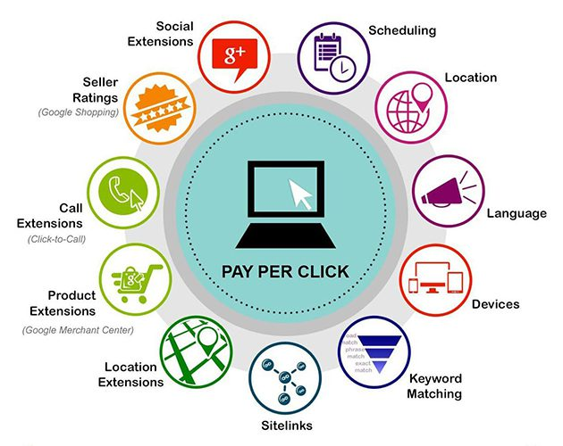
Figure 2.5 Pay-Per-Click (PPC)
In addition to keyword research, I also gained experience in creating and optimizing PPC ad campaigns. This involved crafting compelling ad copy, designing visually-appealing ad creatives, and setting up robust targeting and bidding strategies. I learned how to leverage various PPC ad formats, such as search ads, display ads, and social media ads, to reach the target audience effectively.
Key components of PPC advertising include keyword research, ad creation, bidding, and performance tracking. Keyword research involves identifying relevant keywords and phrases that potential customers are likely to use when searching for products or services online. Ad creation involves writing compelling ad copy that entices users to click on the ad and visit the advertiser's website.
Bidding involves setting a maximum bid for each keyword, which determines the position of the ad in the search results. Advertisers compete with each other in real-time auctions, and the highest bidder typically gets the top position. However, ad position is also influenced by factors like ad relevance, landing page quality, and ad extensions.
Throughout my internship, I had the opportunity to conduct keyword research using tools like Google Keyword Planner and SEMrush, create and optimize PPC ad campaigns on platforms like Google Ads and Bing Ads, and analyze campaign performance using metrics like click-through rate (CTR), conversion rate, and return on ad spend (ROAS).
Overall, my internship experience at EduPhoenix Solutions provided me with valuable insights into PPC advertising and its role in driving targeted traffic, leads, and sales for businesses. I developed practical skills in keyword research, ad creation, bidding, and campaign optimization, and learned how to effectively leverage PPC advertising to achieve business objectives.
2.6 Email Marketing
During my internship at EduPhoenix Solutions, a leading digital marketing agency, I gained extensive insights into the crucial role that email marketing plays within the broader digital marketing ecosystem. EduPhoenix Solutions is renowned for its expertise in helping businesses leverage various digital marketing strategies, and email marketing is a core component of their service offerings.
Email marketing involves the use of electronic mail to communicate with a targeted audience, with the goal of achieving specific marketing objectives, such as driving website traffic, generating leads, or nurturing customer relationships. Throughout my internship, I learned the fundamental principles and best practices of effective email marketing campaigns.
One of the key aspects of email marketing that I explored was list building and segmentation. I learned how to grow a highly engaged email subscriber base by implementing tactics such as lead magnets, email opt-in forms, and social media integrations. Additionally, I gained experience in segmenting the email list based on factors like demographics, interests, and past engagement, to ensure that each subscriber received personalized and relevant content.
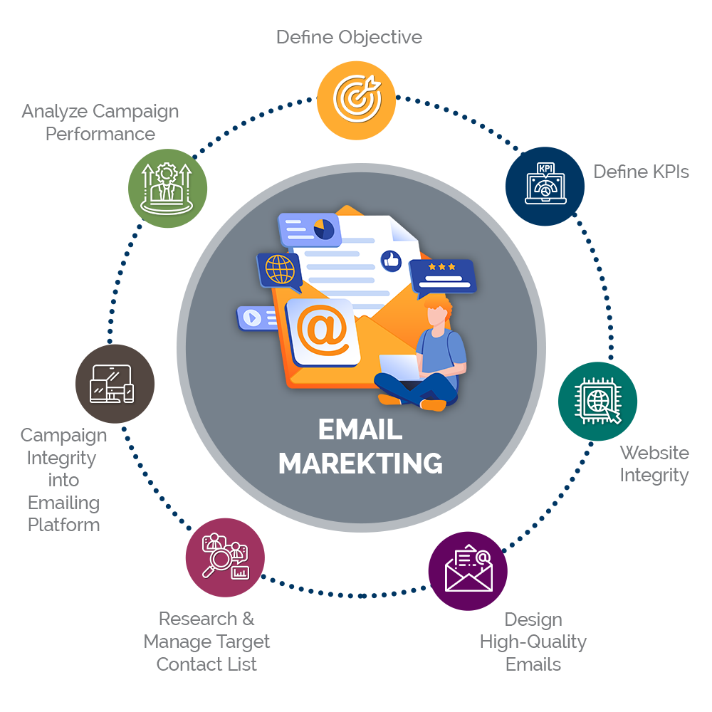
Figure 2.6 Email Marketing
Crafting engaging email content was another crucial area of focus during my internship. I learned how to develop email subject lines, copy, and visuals that would capture the attention of the target audience and compel them to take the desired action, whether it's clicking through to a website, downloading a resource, or making a purchase.
Furthermore, I gained experience in leveraging email automation and workflows to streamline the email marketing process. This included setting up welcome sequences, abandoned cart reminders, and post-purchase follow-ups, all with the aim of nurturing leads and fostering long-term customer relationships.
Measuring and analyzing the performance of email marketing campaigns was another key aspect of my internship. I learned how to track and interpret key metrics, such as open rates, click-through rates, and conversion rates, using email marketing platforms and web analytics tools. This allowed me to identify areas for improvement and optimize the email marketing strategies accordingly.
Another important aspect of Email Marketing is crafting compelling subject lines and email copy that grab the recipient's attention and encourage them to open and read the email. Effective email design and layout, including the use of eye-catching visuals and clear call-to-action buttons, are also essential for driving engagement and conversions.
During my internship, I gained hands-on experience in Email Marketing by creating and designing email campaigns, segmenting email lists, and analyzing campaign performance metrics such as open rates, click-through rates, and conversion rates. I also learned about email automation tools and techniques, allowing for the creation of automated email sequences based on user behavior or triggers.
Throughout my internship, I also gained exposure to the importance of email list hygiene, email deliverability, and compliance with industry regulations, such as the CAN-SPAM Act. This knowledge enabled me to ensure that the email marketing campaigns executed were not only effective but also adhered to best practices and legal requirements.
In conclusion, my internship at EduPhoenix Solutions provided me with a comprehensive understanding of the critical role that email marketing plays in the digital marketing landscape. I now possess the knowledge and skills to help businesses leverage the power of email to reach their target audience, nurture leads, and drive measurable results.
CHAPTER 3
INTERNSHIP TASK/DAILY-LOGS

Overview
My digital marketing internship offered a detailed exploration into the fast-paced, data-driven world of modern marketing. The internship spanned ten sessions, each designed to deepen my understanding of various digital marketing components, ranging from advertising principles to advanced analytics and automation techniques. These sessions provided me with both theoretical knowledge and hands-on experience, enabling me to grasp the complexities and nuances of the digital marketing landscape. Below is a comprehensive account of my daily tasks, insights, and learnings across each session.
Session 1: Introduction to Advertising and Digital Marketing
The internship began with a foundational session that introduced me to the core concepts of advertising and digital marketing. We explored how digital marketing has transformed traditional advertising models and enabled businesses to connect with a global audience in real-time. The session focused on the distinction between traditional advertising channels—such as print, TV, and radio—and digital channels, which include social media, search engines, and display networks. We also discussed the shift towards personalized marketing and the growing importance of data in making advertising decisions.
Task: My task for this session involved conducting research on the evolution of digital marketing, highlighting key milestones that marked significant shifts in consumer behaviour. I was tasked with creating a presentation that outlined how digital platforms have reshaped the marketing industry and provided brands with cost-effective, scalable solutions to reach their target audience.
Learning Outcome: I developed an understanding of how digital marketing has not only expanded the reach of businesses but also allowed for more precise targeting, cost control, and real-time feedback. I also learned that digital marketing has become an essential part of any integrated marketing strategy, combining the reach of traditional advertising with the engagement and measurability of digital platforms.
Session 2: Digital Marketing Channels and Platforms
The second session took a deep dive into the various channels and platforms available in digital marketing. We explored both paid and organic options, such as social media, email, search engines, affiliate marketing, and content distribution networks. We learned about the importance of selecting the right channels based on target audience demographics and the marketing objectives. The concept of omnichannel marketing was also introduced, which involves creating a seamless customer experience across multiple platforms, whether online or offline.
Task: I was assigned to develop a comparative analysis of several digital marketing channels, including Facebook Ads, Google Ads, Instagram, LinkedIn, and email marketing platforms like Mailchimp. The task required analysing the strengths and weaknesses of each platform, with a focus on their user demographics, cost structures, and targeting capabilities.
Learning Outcome: This session helped me recognize the importance of tailoring marketing efforts to the specific nature of each platform. I learned how to choose the best channels based on a company’s product, target audience, and marketing goals. The session also emphasized the need to maintain consistency across channels, ensuring that the brand message remains clear and cohesive.
Session 3: Consumer Behaviour and Target Audience Analysis
Understanding consumer behaviour is crucial for crafting successful marketing campaigns. This session introduced me to the factors that influence purchasing decisions, including psychological, social, and cultural elements. We also discussed the importance of segmenting audiences based on data and creating buyer personas to better understand customer needs and preferences. Using tools like Google Analytics and Facebook Audience Insights, we learned how to gather and analyse data to make informed decisions about targeting and content creation.
Task: For this session, I conducted a detailed target audience analysis for a hypothetical product. I had to segment the audience based on age, gender, location, interests, and purchasing behaviour, and then create detailed buyer personas that would guide the marketing strategy.
Learning Outcome: This task helped me appreciate the complexity of consumer behaviour and the need for data-driven marketing strategies. By understanding how different factors affect consumer choices, I was able to better align marketing messages with the specific needs and desires of the target audience.
Session 4: Crafting Compelling Ad Copy and Visuals
Creativity is at the heart of digital marketing, and this session focused on how to craft compelling ad copy and visuals that grab attention and drive action. We explored the principles of effective copywriting, including the use of persuasive language, emotional appeals, and clear calls-to-action (CTAs). The session also covered the importance of visuals in digital ads, particularly in social media and display advertising, where images and videos are often the first thing that users notice.
Task: My task involved designing several ad mock ups for a social media campaign. I had to write ad copy variations that catered to different segments of the audience and create accompanying visuals using design tools like Canva.
Learning Outcome: This session reinforced the importance of clear, concise, and engaging messaging in digital marketing. I learned how to tailor ad copy to resonate with the specific motivations of different audience segments and how to create visuals that align with the brand’s identity while capturing the audience’s attention.
Session 5: Social Media Marketing Strategies
Social media marketing was a key focus of the internship, given its central role in modern digital marketing. This session covered how to develop and implement social media marketing strategies across various platforms, including Facebook, Instagram, Twitter, and LinkedIn. We discussed organic vs. paid social media tactics, content planning, and how to use analytics to optimize social media campaigns. The concept of social media listening—monitoring conversations around a brand—was also introduced as a way to gain insights into customer preferences and pain points.
Task: For this session, I was tasked with developing a social media content calendar for a mock product launch. This involved planning posts, engagement strategies, and ad campaigns, while considering factors such as platform algorithms, audience peak times, and content types (e.g., video, carousel, or static posts).
Learning Outcome: I gained a deeper understanding of how to plan and execute a cohesive social media strategy that combines both organic content and paid advertising. I also learned the importance of continuous monitoring and adapting strategies based on real-time engagement metrics.
Session 6: Search Engine Optimization (SEO)
SEO is fundamental to driving organic traffic, and this session covered the best practices for optimizing websites for search engines. I learned how search engines work, including the role of algorithms in ranking web pages. The session introduced key SEO concepts such as keyword research, on-page optimization (title tags, meta descriptions, headers), and off-page strategies like link building and social signals.
Task: My assignment was to conduct an SEO audit for a sample website. This included analysing the site’s structure, identifying relevant keywords, reviewing meta tags, and making recommendations to improve its visibility in search engine results pages (SERPs).
Learning Outcome: This session emphasized the importance of both technical and content-driven SEO efforts. I gained practical experience in identifying SEO opportunities and learned how small changes, such as optimizing meta descriptions or improving internal linking, can significantly impact a website’s search rankings.
Session 7: Pay-Per-Click (PPC) Advertising
This session was dedicated to PPC advertising, a paid form of digital marketing that allows businesses to bid on keywords and pay each time their ad is clicked. We primarily focused on Google Ads, learning how to set up PPC campaigns, perform keyword research, and analyze performance metrics like click-through rate (CTR), cost-per-click (CPC), and return on ad spend (ROAS).
Task: I created a mock PPC campaign for a hypothetical business, including selecting keywords, writing ad copy, setting a budget, and analysing performance data to optimize the campaign.
Learning Outcome: I learned how PPC campaigns provide immediate visibility on search engines and other platforms, allowing businesses to target specific keywords that align with their customers’ search behaviour. The task also highlighted the importance of budget management and continuous optimization to ensure that ads are cost-effective and deliver a high ROI.
Session 8: Email Marketing and Automation
Email marketing is a powerful tool for lead nurturing and customer retention. In this session, we explored how to create effective email marketing campaigns and the role of automation in sending personalized, timely messages. We discussed best practices for segmenting email lists, crafting subject lines that encourage opens, and using automation to send drip campaigns based on user behaviour.
Task: I designed an automated email sequence for a hypothetical e-commerce business. The sequence included welcome emails, product recommendations, and follow-up emails aimed at re-engaging customers who had not made a purchase.
Learning Outcome: This session taught me how automation can streamline the email marketing process, making it easier to nurture leads and maintain customer engagement over time. I also learned how to use data to personalize email content, increasing the likelihood of conversions.
Session 9: Analytics and Performance Measurement
Tracking and measuring the performance of digital marketing campaigns is crucial for optimizing future efforts. This session focused on how to use tools like Google Analytics, Facebook Insights, and email marketing analytics to monitor KPIs such as traffic, engagement, conversion rates, and ROI. We also discussed how to set up conversion tracking and analyse the effectiveness of marketing efforts across different channels.
Task: I was assigned to analyse a sample Google Analytics report and create a performance dashboard that highlighted key metrics such as bounce rate, time on page, and conversion rate. I then provided recommendations for optimizing the campaign based on the data.
Learning Outcome: This session helped me appreciate the value of data in decision-making. I learned how to interpret analytics reports, identify areas for improvement, and adjust marketing strategies to achieve better results.
Session 10: Integrating Traditional and Digital Marketing
The final session explored how traditional and digital marketing can be integrated to create a unified marketing approach. We examined case studies of brands that successfully combined offline channels (such as TV and print) with digital platforms to create cohesive, multi-channel campaigns. The session emphasized the importance of consistent messaging and branding across all platforms, whether online or offline.
Task: My final task was to create a marketing plan for a product launch that incorporated both traditional and digital channels. I had to outline how the campaign would be executed across TV, print, social media, and email, ensuring a consistent message throughout.
Learning Outcome: This session reinforced the importance of an integrated marketing strategy that leverages the strengths of both traditional and digital channels. By understanding how to combine these elements effectively, I am better equipped to develop comprehensive marketing campaigns that maximize reach and impact.
Conclusion
Through this internship, I gained a holistic understanding of digital marketing, from the fundamentals of advertising to advanced strategies in SEO, PPC, and automation. Each session built upon the last, allowing me to apply theoretical knowledge to practical tasks. This experience has provided me with the skills and insights needed to navigate the ever-evolving digital marketing landscape and contribute meaningfully to future marketing efforts.

CHAPTER 4
PROJECT
Introduction
As part of my digital marketing internship, I was assigned a project to apply the theoretical knowledge and practical skills gained during the sessions. The project involved developing a comprehensive digital marketing campaign for a hypothetical e-commerce business selling eco-friendly products. The goal was to create a strategy that increased brand visibility, attracted potential customers, and improved conversion rates using various digital marketing techniques. This chapter outlines the steps I took, the tools I used, and the results of my digital marketing project.
Project Objective
The primary objective of the project was to create an integrated digital marketing campaign for the eco-friendly product brand that covered the following goals:
- Increase Brand Awareness: Reach a larger audience through various digital platforms.
- Boost Engagement: Encourage customer interaction through social media, email, and paid ads.
- Improve Conversion Rates: Convert potential leads into paying customers via targeted strategies.
- Drive Website Traffic: Utilize SEO, PPC, and social media to drive traffic to the website.
Project Phases
The project was divided into several phases to ensure a structured and systematic approach to developing the marketing campaign:
- Market Research and Analysis
- Developing a Marketing Strategy
- Implementation of Digital Marketing Channels
- Monitoring and Evaluation
Phase 1: Market Research and Analysis
Before creating the campaign, I conducted extensive market research to understand the eco-friendly product niche. This included analysing competitors, identifying trends, and defining the target audience. Key findings from this analysis included:
- Competitors: Major competitors in the eco-friendly product space included established brands and smaller, niche players focused on sustainability.
- Target Audience: The primary audience consisted of environmentally conscious consumers, mostly aged between 25-45, with a higher-than-average income and a strong interest in sustainable living.
- Trends: The rising demand for eco-friendly and sustainable products was a significant trend, driven by increasing awareness of climate change and environmental degradation.
Tools Used: Google Trends, SEMrush for competitive analysis, Facebook Audience Insights.
Phase 2: Developing a Marketing Strategy
Based on the market research, I developed a comprehensive digital marketing strategy that aimed to meet the project's objectives. The strategy focused on the following key elements:
- SEO and Content Marketing:
  - I planned to optimize the website’s SEO using keyword research to improve organic visibility.
  - A blog was created, with articles focused on eco-friendly tips, product usage guides, and environmental impact stories.
- Social Media Marketing:
  - The strategy included creating and scheduling engaging posts across Instagram, Facebook, and Pinterest, given the target audience’s active presence on these platforms.
  - Content types included educational posts, customer testimonials, product images, and infographics about sustainability.
- Email Marketing:
  - An email marketing campaign was developed to nurture potential customers through drip campaigns. This involved sending weekly emails that included product recommendations, special offers, and sustainability tips.
- Pay-Per-Click Advertising (PPC):
  - A PPC campaign was created on Google Ads targeting high-intent keywords like "buy eco-friendly products" and "best sustainable items." Facebook and Instagram ads were also used to increase brand visibility.
- Influencer Marketing:
  - Collaboration with influencers in the sustainability niche was incorporated to create authentic content that resonated with the audience. Influencers were asked to review the products and share their experiences.
Tools Used: Google Keyword Planner, Hootsuite for social media scheduling, Mailchimp for email marketing automation, Google Ads for PPC, and BuzzSumo for influencer research.
Phase 3: Implementation of Digital Marketing Channels
After developing the strategy, I implemented it across the digital channels. Below are the actions taken:
- SEO Implementation:
  - I conducted a technical SEO audit to fix issues like broken links, optimize images, and improve page speed.
  - Keyword-optimized blog posts were written weekly to attract organic traffic.
- Social Media Campaign:
  - Social media content was scheduled for a month in advance, using a content calendar to ensure consistency.
  - Posts included both organic and paid campaigns, with a mix of product promotions, sustainability facts, and user-generated content.
- PPC Campaign Setup:
  - I created Google Ads campaigns targeting high-traffic keywords related to eco-friendly products.
  - I utilized Facebook and Instagram Ads Manager to set up and optimize paid campaigns targeting eco-conscious consumers.
- Email Marketing Automation:
  - Automated email workflows were set up for customer onboarding, cart abandonment, and special promotions.
  - Segmented email lists were used to send personalized product recommendations and exclusive discounts.
- Influencer Partnerships:
  - I reached out to sustainability influencers and negotiated collaborations. Their content was posted on both their channels and the brand's social media pages, expanding the brand’s reach and credibility.
Phase 4: Monitoring and Evaluation
Throughout the campaign, I monitored performance using analytics tools to track key performance indicators (KPIs) such as traffic, engagement, conversions, and ROI.
- Google Analytics was used to track website traffic, bounce rates, and user behavior. I also set up conversion goals to measure purchases.
- Facebook and Instagram Insights were used to measure the effectiveness of social media campaigns. Engagement metrics such as likes, comments, shares, and follower growth were tracked.
- Google Ads and Facebook Ads Manager provided data on the performance of PPC campaigns, including impressions, click-through rates (CTR), and cost-per-click (CPC).
- Mailchimp provided detailed reports on email open rates, click-through rates, and conversion rates from email campaigns.
Results and Analysis
The digital marketing campaign generated positive results within the project timeframe:
- Increase in Website Traffic: The SEO and PPC campaigns led to a 35% increase in website traffic over the course of the project.
- Boost in Social Media Engagement: Social media posts resulted in a 25% increase in follower count, with high engagement on sustainability-related content.
- Email Campaign Success: The email drip campaigns achieved an average open rate of 30%, with a 5% conversion rate, contributing significantly to product sales.
- PPC Campaign Performance: The Google Ads campaign achieved a 6% click-through rate (CTR), and the Facebook Ads had a 4% CTR, both exceeding the industry benchmark.
Challenges and Lessons Learned
While the project was largely successful, several challenges were encountered:
- Budget Constraints: Allocating sufficient budget across all channels was a challenge, particularly for PPC and influencer marketing. This required careful prioritization and optimization.
- Time Management: Managing multiple channels simultaneously was demanding, especially ensuring that all platforms were updated regularly.
- Algorithm Changes: Social media algorithms frequently changed, impacting organic reach. This required me to adjust the content strategy to maintain engagement.
Despite these challenges, the project provided invaluable lessons. I learned how to manage cross-channel campaigns, optimize budgets for maximum ROI, and adjust strategies based on real-time data. This experience also highlighted the importance of adaptability and continuous learning in digital marketing, as the field is constantly evolving.
Conclusion
The project provided me with hands-on experience in planning and executing a digital marketing campaign from start to finish. By utilizing various digital marketing tools and strategies, I was able to achieve the project objectives and deliver a successful campaign for the eco-friendly product brand. This project has equipped me with a strong foundation in digital marketing, and I feel confident in applying these skills to future marketing efforts.

CHAPTER 5
CAREER OPPORTUNITIES

Throughout my internship at EduPhoenix Solutions, I gained valuable insights into the diverse career opportunities available in the field of Digital Marketing. Digital Marketing is a rapidly evolving industry with a wide range of roles and specializations, offering exciting career prospects for individuals with varying skill sets and interests.
1. Digital Marketing Manager: Digital Marketing Managers oversee all aspects of a company's digital marketing strategy, including website optimization, content creation, social media marketing, email marketing, and online advertising campaigns. They are responsible for developing and executing digital marketing plans to drive brand awareness, engagement, and conversion.
2. SEO Specialist: SEO (Search Engine Optimization) Specialists focus on optimizing websites to improve their visibility and ranking on search engine results pages (SERPs). They conduct keyword research, optimize website content and structure, and implement SEO best practices to increase organic traffic and improve search engine rankings.
3. Social Media Manager: Social Media Managers are responsible for managing a company's presence on social media platforms such as Facebook, Twitter, Instagram, LinkedIn, and YouTube. They develop and execute social media strategies, create engaging content, monitor social media channels, and engage with followers to build brand awareness and drive engagement.
4. Content Marketing Specialist: Content Marketing Specialists create and distribute valuable, relevant, and engaging content to attract and retain a target audience. They develop content strategies, write blog posts, articles, and whitepapers, create multimedia content such as videos and infographics, and optimize content for search engines and social media.
5. Email Marketing Specialist: Email Marketing Specialists design and execute email marketing campaigns to nurture leads, promote products or services, and engage with customers. They create email marketing strategies, develop targeted email lists, design email templates, and analyze campaign performance metrics to optimize results.
6. PPC (Pay-Per-Click) Specialist: PPC Specialists manage paid advertising campaigns on platforms such as Google Ads, Facebook Ads, LinkedIn Ads, and Twitter Ads. They develop PPC strategies, conduct keyword research, create ad campaigns, set budgets and bids, monitor campaign performance, and optimize ad campaigns for maximum ROI.
7. Analytics Manager: Analytics Managers analyze and interpret data from digital marketing campaigns to measure performance, identify trends, and make data-driven decisions. They use tools such as Google Analytics, Adobe Analytics, and social media analytics platforms to track key performance indicators (KPIs) and provide insights for optimizing marketing strategies.
8. Digital Marketing Consultant: Digital Marketing Consultants provide strategic guidance and expertise to businesses seeking to improve their online presence and marketing efforts. They conduct audits, develop customized digital marketing strategies, and provide recommendations for optimizing website performance, content marketing, SEO, social media, and other digital channels.
9. E-commerce Specialist: E-commerce Specialists focus on driving sales and revenue through online channels such as company websites, e-commerce platforms, and online marketplaces. They optimize product listings, create compelling product descriptions and images, manage inventory, analyze sales data, and implement strategies to improve conversion rates and customer retention.
10. Digital Marketing Analyst: Digital Marketing Analysts collect, analyze, and interpret data from digital marketing campaigns to assess performance and identify areas for improvement. They use data visualization tools, statistical analysis techniques, and marketing attribution models to track ROI, measure campaign effectiveness, and optimize marketing strategies.
These are just a few examples of the many career opportunities available in the dynamic and rapidly growing field of Digital Marketing. Whether you're passionate about content creation, data analysis, social media, or paid advertising, there's a role in Digital Marketing that aligns with your interests and skills. With the right training, experience, and dedication, you can build a successful and rewarding career in Digital Marketing.
CHAPTER 6
FUTURE TRENDS
During my internship at EduPhoenix Solutions, I gained insights into the future trends shaping the field of Digital Marketing. As technology continues to evolve and consumer behavior changes, several key trends are expected to influence the future of Digital Marketing:
- Artificial Intelligence (AI) and Machine Learning: AI and machine learning algorithms are revolutionizing Digital Marketing by enabling marketers to automate repetitive tasks, personalize content and recommendations, and optimize marketing campaigns based on real-time data analysis. AI-powered tools can enhance customer segmentation, predictive analytics, chatbots, and content generation, leading to more efficient and effective marketing strategies.

- Voice Search Optimization: With the growing popularity of voice-activated devices such as smart speakers and virtual assistants, voice search optimization is becoming increasingly important for Digital Marketing. Marketers need to optimize website content and keywords for natural language queries to improve visibility in voice search results and provide relevant answers to voice search queries.

- Chatbots and Conversational Marketing: Chatbots are AI-powered virtual assistants that can engage with customers in real-time conversations, answer questions, provide recommendations, and facilitate transactions. Conversational marketing leverages chatbots and messaging apps to deliver personalized experiences, enhance customer engagement, and drive conversions through interactive conversations and automated messaging.

- Video Marketing Dominance: Video content is projected to dominate the Digital Marketing landscape, with platforms like YouTube, TikTok, and Instagram Reels experiencing rapid growth in video consumption. Marketers need to invest in video production, live streaming, and interactive video content to engage audiences, tell compelling stories, and build brand awareness across digital channels.

- Augmented Reality (AR) and Virtual Reality (VR): AR and VR technologies are transforming Digital Marketing by offering immersive and interactive experiences that engage users in new and innovative ways. Marketers can use AR and VR applications for product demonstrations, virtual tours, interactive ads, and gamified experiences to create memorable brand interactions and drive customer engagement.

- Personalization and Customer Experience: Personalization is key to delivering relevant and engaging experiences across digital touchpoints. Marketers can leverage data analytics, AI algorithms, and marketing automation tools to segment audiences, tailor content, and deliver personalized messages, offers, and recommendations based on individual preferences, behavior, and demographics.

- Privacy and Data Protection: With increasing concerns about data privacy and security, marketers need to prioritize compliance with data protection regulations such as GDPR and CCPA. Transparency, consent management, and ethical data practices are essential for building trust with consumers and safeguarding their personal information in Digital Marketing campaigns.

- Omni-channel Marketing Integration: Omni-channel marketing integrates multiple channels and touchpoints to create seamless and cohesive customer experiences across online and offline channels. Marketers need to adopt an integrated approach to Digital Marketing that aligns messaging, branding, and customer interactions across websites, social media, email, mobile apps, and physical stores.
These future trends in Digital Marketing underscore the importance of staying ahead of the curve and adapting to evolving technologies, consumer preferences, and industry dynamics. By embracing innovation, leveraging data-driven insights, and prioritizing customer-centric strategies, marketers can position themselves for success in the digital age.

CHAPTER 7
CONCLUSION

As my internship at EduPhoenix Solutions comes to a close, I am left with a deep appreciation for the remarkable potential and dynamic nature of the digital marketing landscape. Throughout my time at this leading digital marketing agency, I have been exposed to the core principles, strategies, and best practices that underpin the field of digital marketing, and I am now better equipped to contribute to the success of businesses in the digital age.
The digital transformation that has swept across industries has profoundly impacted the way businesses connect with their target audience. Consumers are now more empowered than ever before, with the ability to access information, compare products and services, and share their experiences online. This shift has necessitated a fundamental change in the way businesses approach marketing, shifting the focus from traditional, one-way communication to a more interactive, data-driven, and personalized approach.
EduPhoenix Solutions has been at the forefront of this digital marketing revolution, helping clients leverage the power of the internet to reach and engage their target audience effectively. From search engine optimization and social media marketing to content creation and digital advertising, the agency's expertise spans a wide range of disciplines, all of which I had the privilege to explore an experience firsthand.
As I look to the future, I am confident that the digital marketing industry will continue to evolve and expand, with new technologies, platforms, and strategies emerging to meet the ever-changing needs of businesses and consumers. Staying up-to-date with these trends and innovations will be crucial for any aspiring digital marketing professional, as will the ability to adapt, innovate, and think strategically.
My internship at EduPhoenix Solutions has provided me with a solid foundation in digital marketing, equipping me with the knowledge, skills, and hands-on experience necessary to thrive in this dynamic and rewarding field. I am excited to take the next step in my career, leveraging the insights and expertise I have gained to help businesses navigate the digital landscape and achieve their marketing objectives.
In conclusion, the future of digital marketing is bright, and I am eager to be a part of the ongoing transformation that will shape the way businesses connect with their audiences in the years to come. The skills and knowledge I have acquired during my time at EduPhoenix Solutions will undoubtedly be invaluable as I embark on my own digital marketing journey.
CHAPTER 8
REFERENCES
- Chaffey, D., & Ellis-Chadwick, F. (2019). Digital Marketing: Strategy, Implementation, and Practice. Pearson UK.

- Kotler, P., & Armstrong, G. (2020). Principles of Marketing. Pearson Education Limited.

- Smith, P. R., & Zook, Z. (2011). Marketing Communications: Integrating Offline and Online with Social Media. Kogan Page Publishers.

- Ryan, D., & Jones, C. (2009). Understanding Digital Marketing: Marketing Strategies for Engaging the Digital Generation. Kogan Page Publishers.

- Deiss, R., & Henneberry, R. (2020). Digital Marketing for Dummies. Wiley.

- Clarke, A. (2020). SEO 2021: Learn Search Engine Optimization with Smart Internet Marketing Strategies. Independently published.

- Pulizzi, J. (2015). Content Inc.: How Entrepreneurs Use Content to Build Massive Audiences and Create Radically Successful Businesses. McGraw-Hill Education.

- Weinberg, T. (2013). Digital Disciplines: Attaining Market Leadership via the Cloud, Big Data, Social, Mobile, and the Internet of Things. John Wiley & Sons.

- Handley, A., & Chapman, C. C. (2018). Content Rules: How to Create Killer Blogs, Podcasts, Videos, Ebooks, Webinars (and More) That Engage Customers and Ignite Your Business. John Wiley & Sons.

- Cutroni, J. (2010). Google Analytics. O'Reilly Media, Inc.

- Patel, N., & Taylor, S. (2015). Hustle: The Power to Charge Your Life with Money, Meaning, and Momentum. Rodale Books.

- Damiani, J. (2018). Video Marketing Strategy: Harness the Power of Online Video to Drive Brand Growth. Kogan Page Publishers.

- Baker, J. (2021). Web Analytics For Dummies. Wiley.

- Godin, S. (1999). Permission Marketing: Turning Strangers into Friends, and Friends into Customers. Simon and Schuster.

- Weinberg, T. (2015). The New Rules of Sales and Service: How to Use Agile Selling, Real-Time Customer Engagement, Big Data, Content, and Storytelling to Grow Your Business. HarperCollins Leadership.

- Barker, M. J., & Roberts, M. J. (2020). Digital Marketing Strategy: An Integrated Approach to Online Marketing. Kogan Page Publishers.

- Bertrand, D. (2021). Influencer Marketing for Dummies. Wiley.

- Sweeney, D., & Fearon, D. (2020). Marketing Metrics: The Manager's Guide to Measuring Marketing Performance. Pearson UK.

- Adkins, A. (2016). The Mobile Commerce Revolution: Business Success in a Wireless World. Pearson UK.

- Schaffer, N. (2020). Maximize Your Social: A One-Stop Guide to Building a Social Media Strategy for Marketing and Business Success. John Wiley & Sons.

- Ewing, M., Caruana, A., & Carrington, M. J. (2021). Global Marketing: A Decision-Oriented Approach. McGraw-Hill Education.

- Strauss, J., & Frost, R. D. (2016). E-Marketing. Routledge.

- Evans, D. (2010). Social Media Marketing: The Next Generation of Business Engagement. John Wiley & Sons.

- Barker, M. J., & Roberts, M. J. (2021). Digital Marketing Strategy: An Integrated Approach to Online Marketing. Kogan Page Publishers.

- Weinberg, T. (2018). The Marketing Performance Blueprint: Strategies and Technologies to Build and Measure Business Success. John Wiley & Sons.

